

**Inventors**



**إعداد الطالب:**

**Alexander Graham Bell**

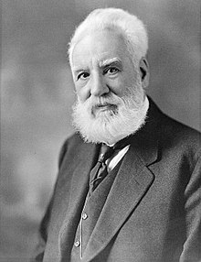Alexander Graham Bell (March 3, 1847 – August 2, 1922) lexander Bell was born in Edinburgh was a Scottish-born scientist, inventor, engineer, and innovator who is credited with patenting the first practical telephon and founding the American Telephone and Telegraph Company (AT&T) in 1885.

**Nikola Tesla**

Nikola Tesla (/ˈtɛslə/; Serbian Cyrillic: Никола Тесла Serbo-Croatian pronunciation: [nikoːla tesla]; 10 July 1856 – 7 January 1943) Born and raised in the Austrian Empire , was a Serbian-American inventor, electrical engineer, mechanical engineer, physicist, and futurist who is best known for his contributions to the design of the modern alternating current (AC) electricity supply system.

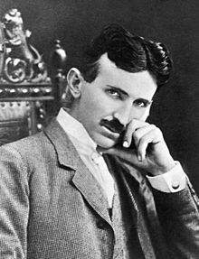

**Martin Cooper**

Martin "Marty" Cooper (born December 26, 1928) is an American engineer. born in Chicago, Illinois, United States He is a pioneer in the wireless communications industry, especially in radio spectrum management, with eleven patents in the field.

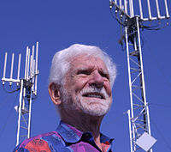

**Steven Jobs**

Steven Paul Jobs (/dʒɒbz/; February 24, 1955 – October 5, 2011) born in San Francisco, California, US , was an American entrepreneur, business magnate, inventor, and industrial designer. He was the chairman, chief executive officer (CEO), and a co-founder of Apple Inc., CEO and majority shareholder of Pixar, a member of The Walt Disney Company's board of directors following its acquisition of Pixar, and the founder, chairman, and CEO of NeXT. Jobs and Apple co-founder Steve Wozniak are widely recognized as pioneers of the microcomputer revolution of the 1970s and 1980s.

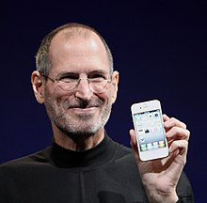

**References:**

* Wikipedia
* https://www.biography.com/people/