**Modern technology**

[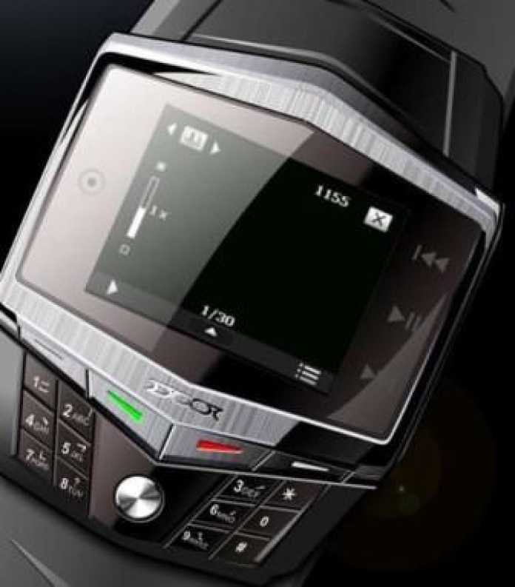](http://www.useoftechnology.com/wp-content/uploads/2012/11/Ultra-thin-Quad-band-Watch-Mobile-Phone.jpg)

[**Modern technology**](http://www.useoftechnology.com/technology-2013-technology-concepts/) **is simply an advancement of old technology**, the [**impact of technology in modern life**](http://www.useoftechnology.com/7-location-based-apps/) is unmeasurable, we use technology in different ways and sometimes the way we implement various technologies ends up harming our lives or the society we leave in. What we call modern technology is technically not so new in most cases. For example, mobile phone technology has evolved with years, nowadays we use [**smartphones**](http://www.useoftechnology.com/use-of-cell-phone-school/) which have been an advancement of an ordinary mobile phone.

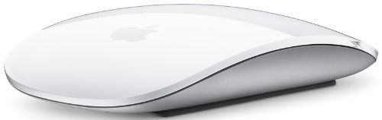

Technology is applied to the roles each individual fulfills during life. We [**use technology**](http://www.useoftechnology.com/how-to-use-technology/) on a daily basis to accomplish specific tasks or interests. Modern Technology increases human capabilities and this technology has evolved with years. What used to work before, might not be working now, it must have got old or got replaced by [**modern technology**](http://www.useoftechnology.com/workplace-business-technology/). Let’s look at a simple example in Transportation technology, this technology has evolved with years, we used to use steam powered trains now those have been replaced by electronic trains which move faster than steam trains.

Modern technology simplifies life in so many ways and everyone defines technology in their own way. To some people, it means [**complicated electronic devices**](http://www.useoftechnology.com/desktop-computers-business/). To others, it means the source of the radical changes that are happening in all phases of life. Others define technology as science applied to practical purposes. Some people fear to use technology while others see it as the source of longer and more complete lives.  **Below I have listed detailed points on Advantages and Disadvantages of Modern Technology:**

**5 ADVANTAGES OF MODERN TECHNOLOGY:**

* **Easy Access to information**: It has become very easy to get access to relevant information at any time anywhere. This has been possible because of modern technologies like broadband internet.  Lots of data is being published and indexed online, sites like Wikipedia and Youtube have great original content which can be used in research or entertainment. [**Information**](http://www.useoftechnology.com/impact-information-technology-organization/)is power and those who find information and use it well always succeed.  With smart gadgets like the iPad, iPhone, galaxy tablet, users can easily have access to information through these smart gadgets because they use the internet. So a user on a train can easily read breaking news while traveling, they can also buy and sell stocks while in the bedroom using the internet. These smart gadgets make it easy to access the internet and this simplifies the way we get information.

* **Encourages innovation and creativity** – Since technology is challenging, it sparks the brain to [**work**](http://www.useoftechnology.com/technology-workplace-2/) to its full potential.  In the past, it used to be very difficult to start a business, one had to have lots of capital and they even had limited access to business information. Today, it is very easy to start a business while at home. Let’s look at companies like Etsy.com which enable creative people to sell their works online, this encourages creativity. Another good example is [kickstarter.com](http://kickstarter.com) which helps creative people get funds for their projects through crowdfunding. On this platform, creative developers post projects seeking funding from the community, this helps them generate lots of cash for their good ideas which latter leads to the creation of new Jobs.  The other creative works which have been facilitated by modern technology include  Google, Apple, Facebook, Microsoft, Amazon,  etc

* **Improved communication**:   Communication is like water to life. We can not develop without [**communication**](http://www.useoftechnology.com/communication-technologies/).  Modern technology has blessed us with advanced communication technology tools. These can include e-fax machines, electronic mail, mobile phones, [**video conferencing**](http://www.useoftechnology.com/virtual-meeting-technologies/), instant text messaging applications, social networking applications. All these modern communication technology tools have simplified the way humans and businesses communicate.  I can easily talk to my relative overseas using a mobile phone or video chatting services like Skype.

* **The convenience of Traveling**:  Modern transportation technology makes it very easy to travel long distances.  Transport is a very important both in our lives and in the business world.  Transportation technology has evolved with years. In the past, it used to be slow and expensive to move long distances. Nowadays, I can cover a 10 miles distance within a few minutes or hours  using electric trains or airplanes.

* **Improved housing and lifestyle**: This is another great way how modern technology has simplified our lives. If you compare the type of housing we used to have in 1900 and the architecture of houses today, the difference is very big. New architectural technology has improved the types of housed we build nowadays.   People with money can afford town floating housed   and glass homes. Most of the items in our house are now automated, for example, doors use fingerprints which guarantee security.  Remote webcams which you can use to monitor what goes on at your home.

**4  EXAMPLES OF MODERN TECHNOLOGIES WHICH CAN SIMPLIFY YOUR LIFE:**

**Ultra-thin Quad-band Watch Mobile Phone:**

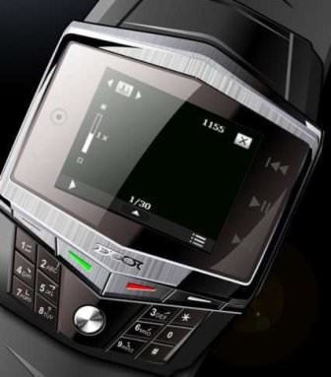

This is a modern watch which comes with basic functions of a mobile phone, it will simplify the way you communicate, you no longer have to worry about losing or misplacing your cell phone, now this new technology puts all basic features of a cell phone in a watch, it has a high-definition display, MP3 ringtones, audio tone, it supports multimedia messaging, and so much more. This advancement in communication technology makes me wonder if cell phones will be replaced by watch phones. For those who hate carrying cell phones all the time, this is a great option, you can easily set this watch phone in vibration and connect it to your blue tooth, I guarantee you will not miss any business or important call.**Apple Magic Mouse**



Simple and elegant wireless mouse from Apple, you can improve your workplace experience by using this Apple Magic Mouse, it comes in a smooth shell design supported by both touch-sensitive and Bluetooth technologies which make it different from the usual mouse you have. Though you will need a little bit of adjustment if it is your first time to use this Apple Magic Mouse, it is too smooth and very responsive, for those who enjoy playing video games, this Apple Magic Mouse will improve your computer gaming experience. It is so lovely, for those who love Apple products.

**Kingston Digital DataTraveler**  
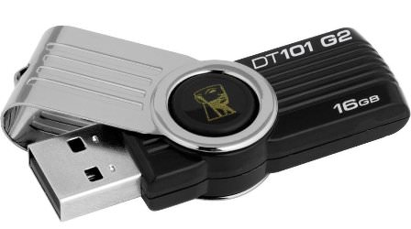

You can easily transfer and move with your data using this Kingston Digital DataTraveler. Many times we back up our data on cloud servers, but these servers are not 100% safe, some prefer backing a copy of my data on a flash drive, this Kingston Digital DataTraveler has 16GB of storage space, so you can store as much data as you want, its size is slim, it can fit in your wallet. This Kingston Digital DataTraveler supports Windows 8, Windows 7, Vista, XP and Mac. The cap on the top is fixed on the drive, so you will not lose it. You can easily drag-and-drop files, photos, videos, music and so much more on this Kingston Digital DataTraveler. Simplify the way you move your data with this slim data traveler.

**Apple iPad 2**

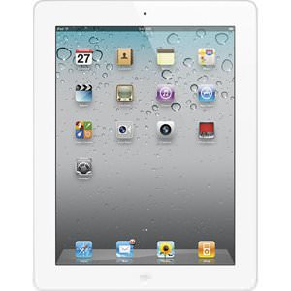

Tablets have simplified the way we perform various computer-based tasks, both students and business people are using these tablets to accomplish different tasks. The functions of this Apple iPad 2 are limitless, for example, you can use it as a video conference

ing tool, use it as a presentation tool in a business meeting or classroom, use it to edit business documents or write classroom notes. when it comes to storage, this Apple iPad 2 comes with 64GB of data storage space, quite enough space for all your files, music, photos, software and so much more. From today, you don’t need to travel with a laptop, try out this Apple iPad 2 and simplify the way you do most computer tasks.

**SATA Hard Drive Docking Station:**

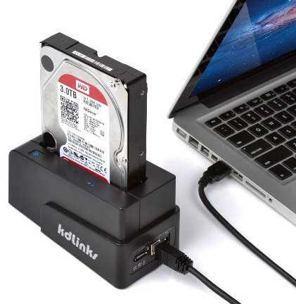  
Work smart and secure your data by using this SATA Hard Drive Docking Station, it will hold your SATA Hard Drive firmly so you will not worry about damaging your hard-disk and it also comes with a USB port which makes it easy to access or backup data on your SATA Hard Drive directly from your laptop. The transmission speed is up to 5Gbps. You